**THE ROY WATHERSTON**

**MEMORIAL TRUST**

**EDUCATIONAL**

**TRAVEL AWARDS**

Administered by:

**The Royal Highland & Agricultural Society of Scotland**

Royal Highland Centre

Ingliston

Edinburgh

EH28 8NB

0131 335 6200

[reception@rhass.org.uk](mailto:reception@rhass.org.uk)

www.rhass.org.uk

**THE ROY WATHERSTON MEMORIAL TRUST**

*The Trust was established to commemorate the life, work and achievement of the late Roy Watherston, Crichton Mains, Ford, Midlothian, an outstanding farmer and breeder of Shorthorn cattle, someone who had a keen interest in the practical education of young people.*

*The trustees represent the Beef Shorthorn Cattle Society, the Royal Highland and Agricultural Society of Scotland, SRUC, the Scottish Association of Young Farmers’ Clubs and the Watherston family.*

*The trust offers education travel awards to any young persons, preferably under thirty years of age, who have a sound practical basis in agriculture or a related rural industry, upon which to build using the experience to be gained by education through travel, and who can demonstrate that on their return they will be able to use this experience in a practical way.*

*The amount of an individual award may vary from £500 up to £2,500.*

*Anyone interested should send for an application form to the Honorary Secretary at the address on the front page of this booklet.*

**APPLICATION & SELECTION**

*Applications may be sent at any time of year and are considered on the basis of those who have the requisite countryside experience, a genuine and feasible project for study abroad and the ability to use the experience in a practical way in the United Kingdom on their return. Potential candidates will be interviewed by the Trustees.*

*Assistance can also be given with making contacts and arrangements to pursue the chosen project, which must be undertaken at any time within one year of the award being made. The recipient of an award must submit a written report to the Trustees within three months of completion and may be invited to make a presentation to the Trustees.*

*Those interested in making an application should contact the Honorary Secretary (contact details on the front cover) for an official application form.*

**Some recent study projects undertaken…**

* INTENSIVE FARMING ON SMALL HILL AND UPLAND UNITS IN GERMANY
* BEEF PRODUCTION IN CANADA
* STUDY OF HYDROPONICS IN THE USA
* FORESTRY MANAGEMENT IN FINLAND
* IRRIGATED VEGETABLE PRODUCTION IN MALAYSIA
* SHEEP PRODUCTION IN FRANCE
* GOAT PRODUCTION IN NEW ZEALAND
* AGRICULTURAL EDUCATION IN THE CLASSROOM IN DENMARK
* RAPE SEED PRODUCTION IN CANADA
* COMMERCIAL PROSPECTS OF MARKETING BRITISH MEAT TO RUSSIA
* STUDY RURAL ORGANISATIONS & LEADERSHIP IN THE AGRI-FOOD INDUSTRY IN CANADA
* BEEF AND LAMB MARKETING CHANNELS IN NEW ZEALAND
* STUDY OF THE CANADIAN BEEF INDUSTRY
* STUDY OF SHEEP IN NEW ZEALAND

**RWMT Case Studies…**

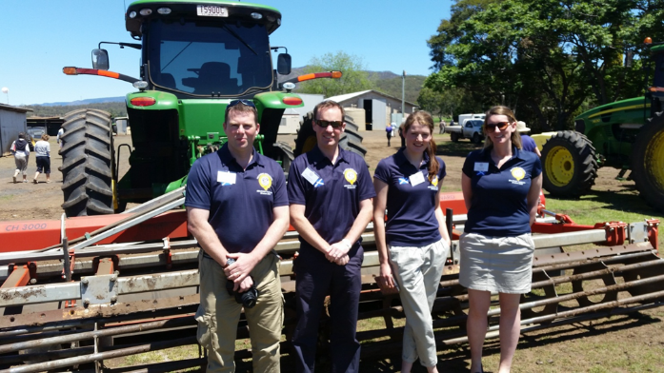

***Katrina McDowall – Attendance at RASC Conference, Brisbane 2014***

*“I applied for the RWMT travel scholarship in 2014 because I believe it is crucial to look beyond your local situation and travel to see and learn from others within your industry. The funding I received took me to the Commonwealth Agricultural Conference in Brisbane, and gave me the chance to learn about topics the whole of the Commonwealth are discussing to benefit the future of agriculture. The industry is only going to become increasingly interconnected across the world and the funding I received allowed me to meet people from all across the Commonwealth to learn about topics which affect us all. To be able to visit farms in another country that are so progressive and forward thinking was fantastic and a real eye opener. The topics covered at the conference itself were so relevant and to be able to listen to experts in their field on such important issues was a valuable experience.*

*I can only thank the RWMT again for their support”*

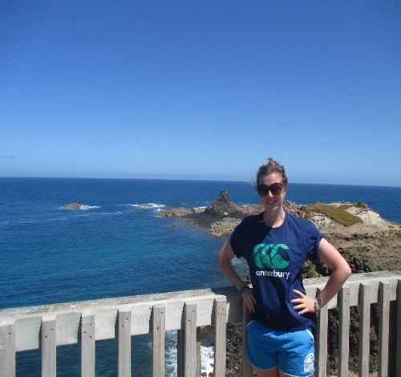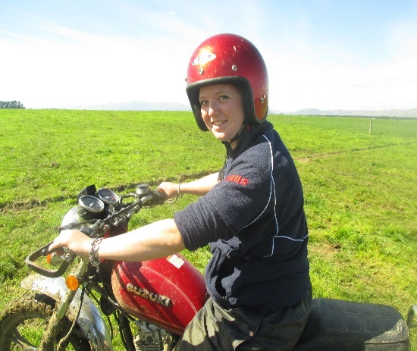

***Laura Mitchell – Beef study tour of Australia & New Zealand***

*“I was lucky enough to be awarded funding from the RWMT in 2013.*

*Whilst studying Agriculture at University, I carried out my dissertation looking into the on-farm factors affecting the eating quality of beef. I found this topic really interesting and was keen to learn more. I applied to the RWMT and was lucky enough to be awarded funding which enabled me to travel to Australia to see how their eating-quality based grading system for beef worked first hand. I visited several different farms ranging from holdings with 100 head of cattle to feedlots with 33,000 head of cattle. I also got the opportunity to visit an abattoir which practiced the eating quality focussed grading system which Australia is famous for.*

*I travelled to New Zealand and visited several beef farms there.*

*Travelling to a different country to study a topic of interest was very rewarding and allowed me to get a real insight into the subject, instead of just reading it from a book.*

*I would highly recommend that anyone looking to travel and lear about Agriculture in a different country apply to RWMT, you won't regret it!”*